___________________________________________________________________
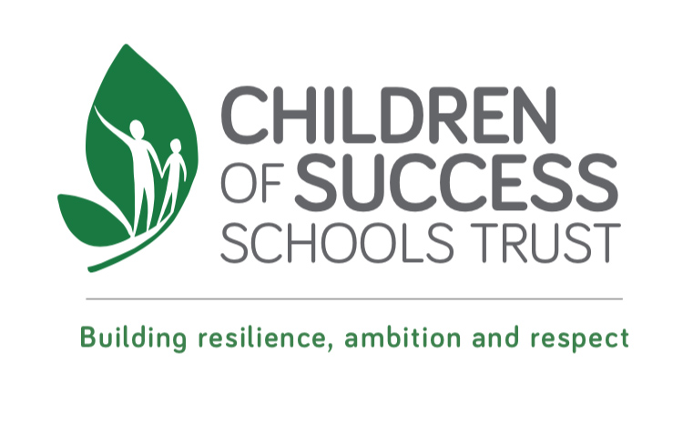

Job Description

Reporting
The post holder reports to the site manager.
Apart from team members, the main contacts of the job are other School staff, pupils and members of the public.

Main Purpose of the Job

To provide effective cleaning services within the school. ___________________________________________________________________

Main Duties
- Cleaning the school premises including deep cleaning
- Vacuuming carpeted areas and washing floors of cloakrooms and toilets in designated areas
- Sweeping uncarpeted areas
- Emptying and cleaning bins and disposing of rubbish in main bins
- Spot cleaning of spillages
- Cleaning desks, seats and skirting boards
- Cleaning toilet areas and replenishing toiletries
- Cleaning doors and windows
- Checking stock levels of cleaning materials
- Report all defects/hazards immediately to the caretaker or supervisor
- Carry out duties in a safe and responsible manner in accordance with requirements under Health & Safety regulations, established safe systems of work, practices and procedures.

- Assist in the care of equipment, materials and storage areas used in cleaning the building.

- Participate in training as required.

___________________________________________________________________

Where the post holder is disabled, every effort will be made to supply all the necessary aids, adaptations or equipment to allow them to carry out all the duties of the job. If however, a certain task proves to be unachievable, job redesign will be given full consideration.

___________________________________________________________________

Person Specification

Cleaner
Education – School Based Staff

For this job we are looking for a person with:

- An ability to carry out cleaning functions and associated duties to the specified standards
- A reasonable level of fitness
- Who is punctual, reliable and trustworthy
- Able to manage time effectively
- Ability to work both alone and in a team developing good relationships.
- Awareness of health and safety procedures
- Reading skills for following instructions, understand simple instructions.
- Maths skills for measuring cleaning fluids

Personal Style and Behaviour

- Positive outlook taking a pride in good cleaning work
- Willingness and ability to work flexibly and to undertake any other duties which contribute to the delivery of Schools services.

